

**Assessment: Major Project**

**Part 1**

Author: Bertocco Thomas-Killian - #13758322

Lecturer: Dr. Yeli Feng

CP5608 Advanced Animation Techniques | SP51 | 2020

29 April 2020

# Description

My animation takes place in a mountainous desert. There is a war between two factions: knights and monsters. The knight comes out of his castle and watches the little monsters fighting. A second character enters the scene and roars to challenge the knight. He then runs at the knight and starts to hit him. The monster punches the knight, but he is too small, so he cannot harm him. The knight looks at him, then hits him to get rid of him.

# Animation Plan

Step 1: Show the main character (the knight).

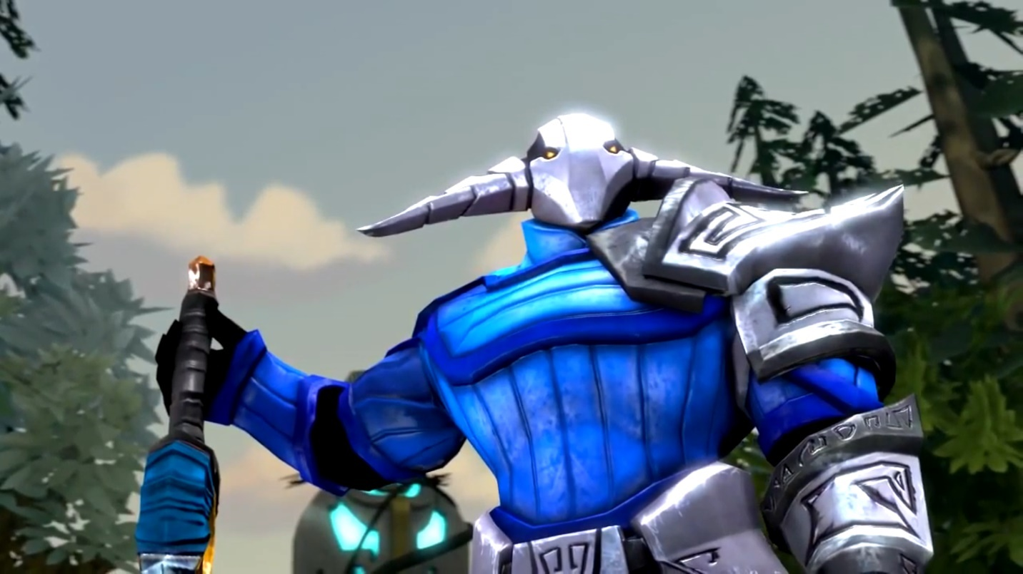

Step 2: Show what the knight is looking at.

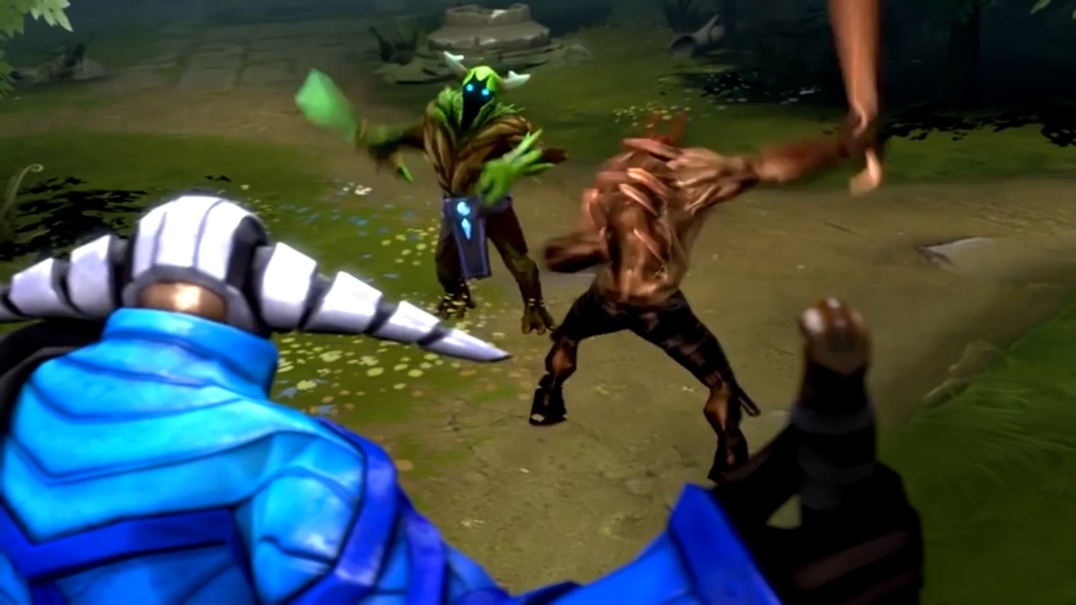

Step 3: The main enemy appears and roars.

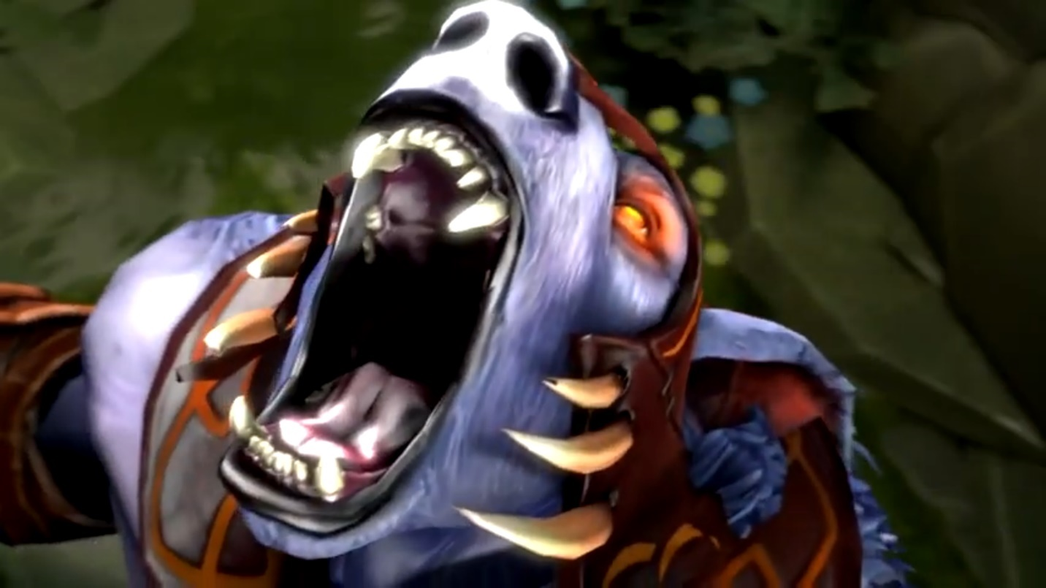

Step 4: The knight notices the enemy

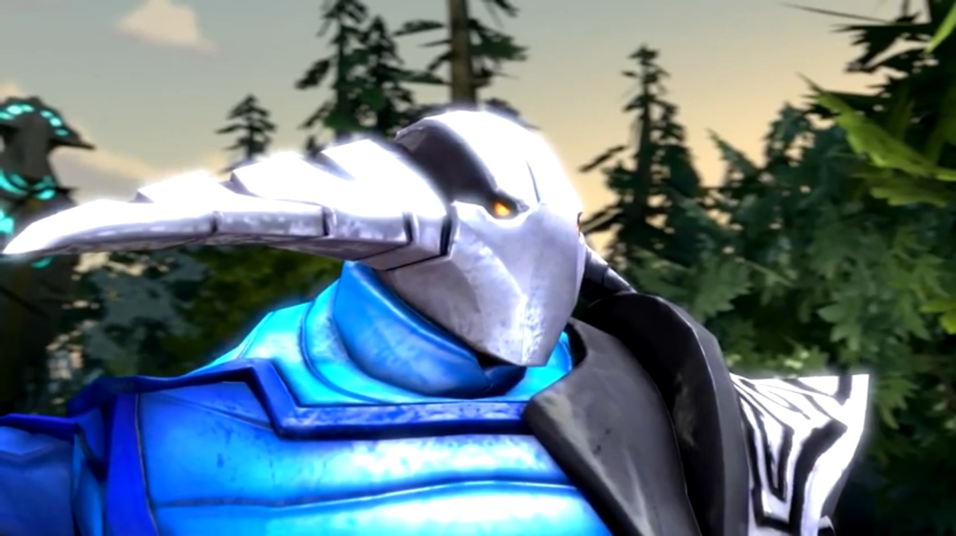

Step 5: The enemy starts running towards the knight

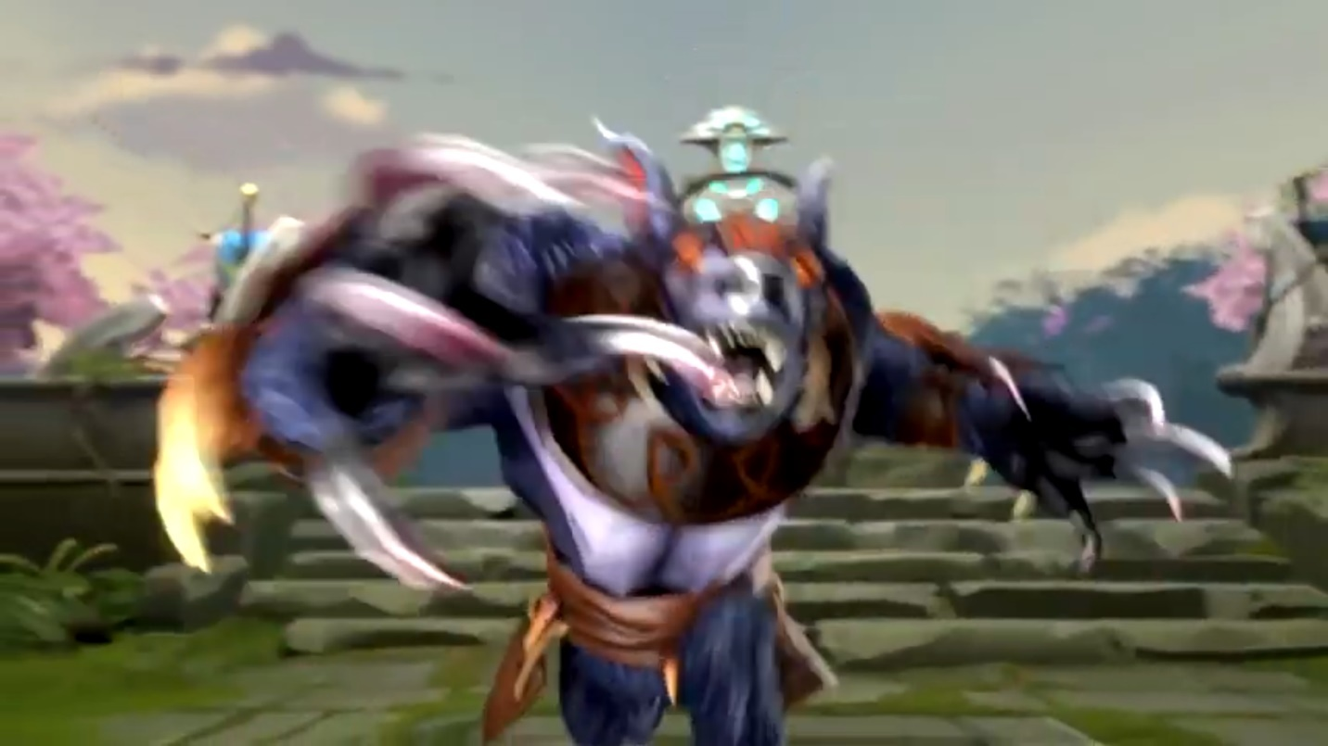

Step 6: View from the side, we now understand that the enemy is tiny…

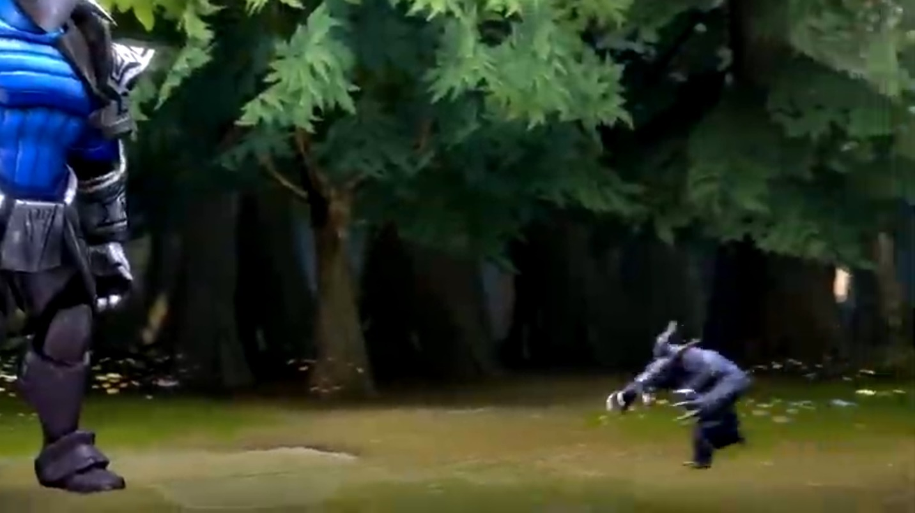

Step 7: The monster punches the knight (the knight does not react)

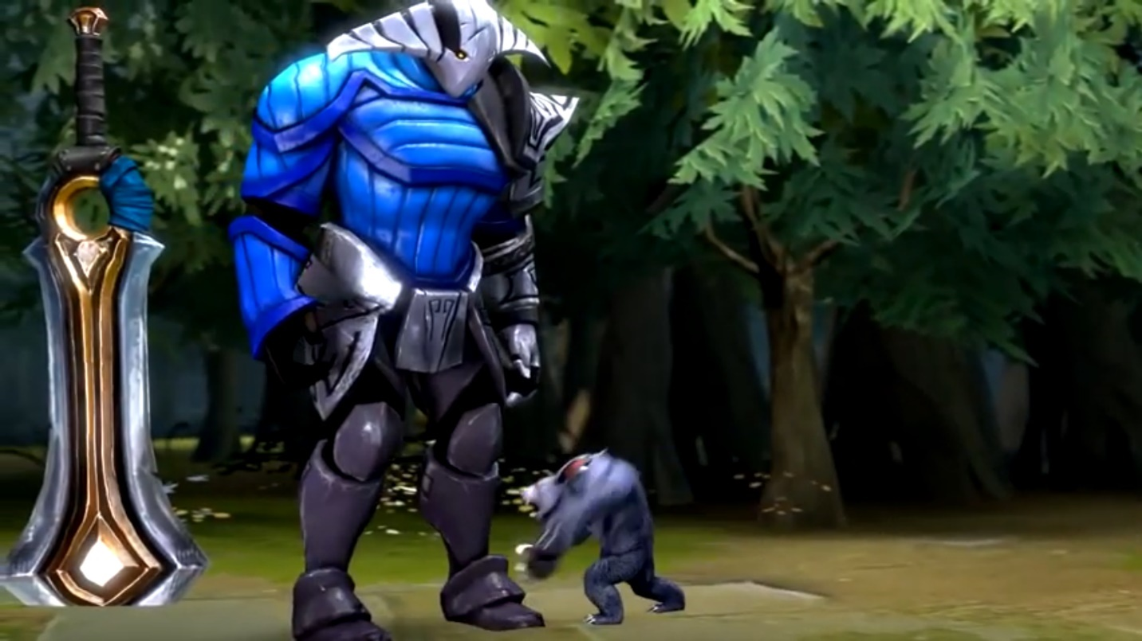

Step 8: The knight kicks the monster.

Step 9: Show the monster being kicked out of the map.

# My scenes

The terrain + castle

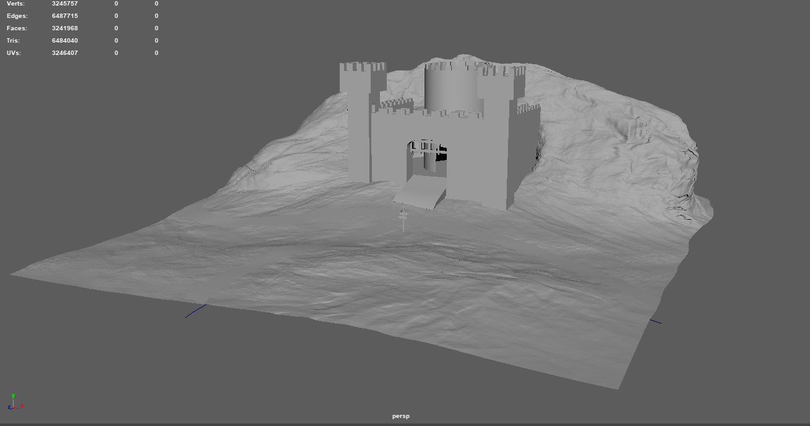

The knight

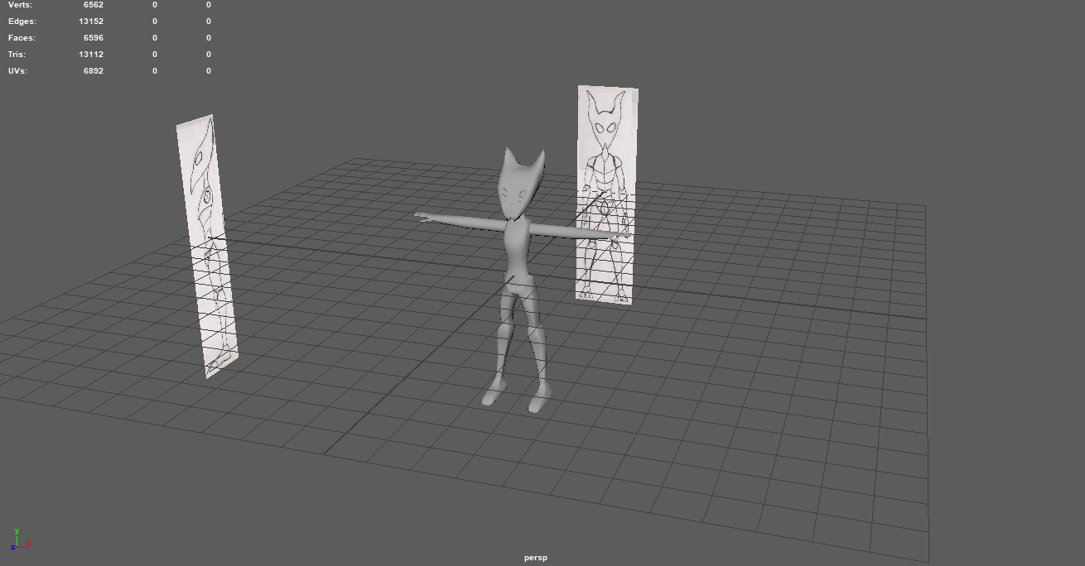

The minion (for animation step 2)

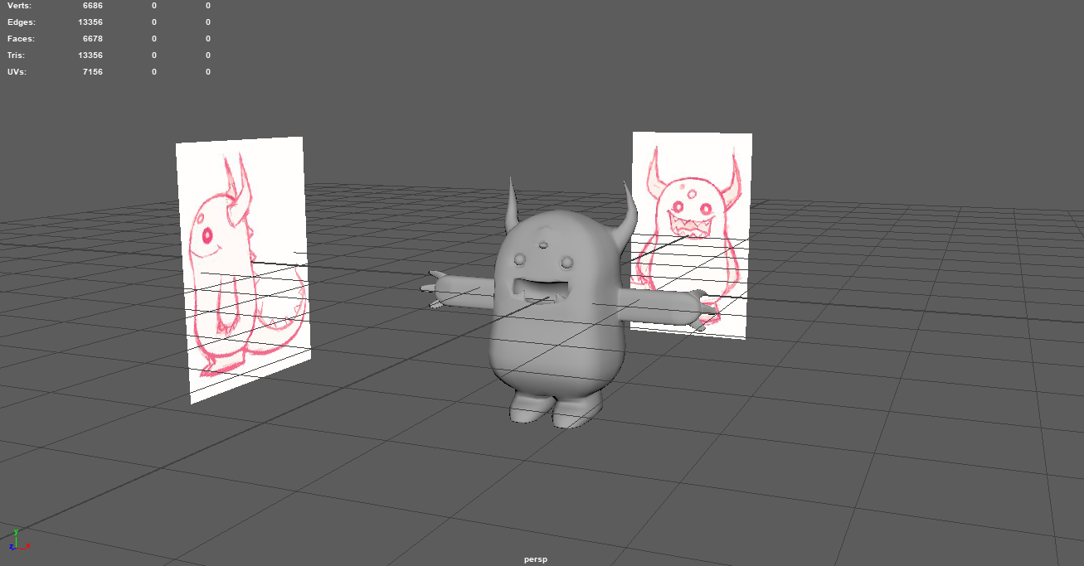

The main enemy

